|  |  |  |  |
| --- | --- | --- | --- |
| **F:\Learning bugs\Foundation Subjects\Dolly the Fly - Science.jpgLyng Primary School Knowledge Organiser** | | | |
| **Topic: Plant reproduction** | **Science**  **What is the life cycle of a flowering plant?** | Year 3 | Summer 1 |

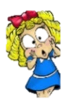

**Notable scientists**

**Agnes Arber**

**She was a pioneering botanist who studied plants.** 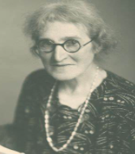

**What should I already know?**

* Seeds and bulbs grow into seedlings.
* Seeds and bulbs grow by producing shoots.
* The parts of plant – roots, stem, leaves and flowers.
* I know that seeds need warmth and water in order to germinate.
* I understand that plants need water, light and suitable temperature for growth and health.

|  |  |
| --- | --- |
| **What Step On and Goldilocks words will I use?** | |
| **Spelling** | **Definition** |
| absorb | To take in or soak up a liquid |
| germination | A process where a new plant grows from a seed |
| pollen | A fine powder found in the male part of a plant |
| pollination | A process where pollen is transferred from a male plant to a female plant |
| disperse | To distribute or disperse seeds over a wide area |
| transport | To take, carry or move |
| nutrients | Substances that a plant needs to survive |
| roots | A part of a plant that is underground |
| stem | A part of a plant that supports and transports materials to other parts of a plant |
| petal | A part of a flowering plant that is usually brightly coloured |

|  |
| --- |
| Investigate! |
| * Set up an enquiry to test water transport in plants. Place a celery stick in coloured water to observe the water transportation. Leave it for 24 hours and see what happens! * Complete and interpret data in a bar chart to answers the question ‘How does light affect plant growth?’ |

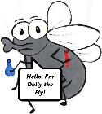

**What will I know by the end of the unit?**

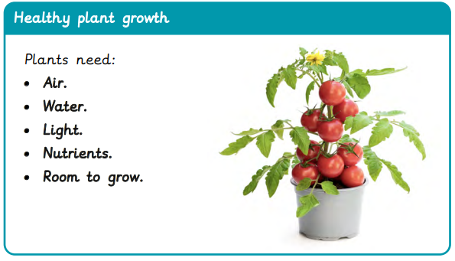

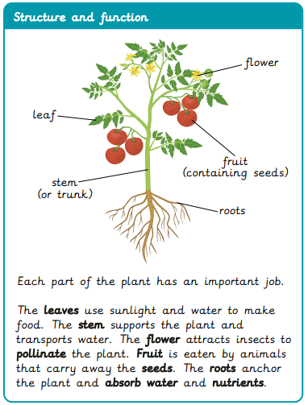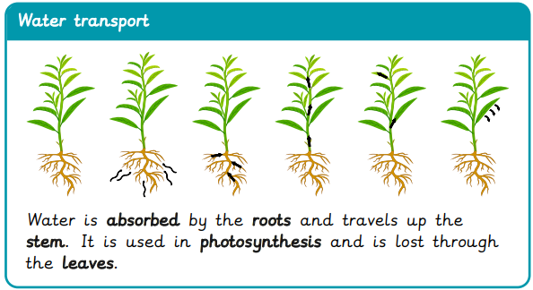

|  |
| --- |
| Our Enquiry Questions |
| * What are the growth and survival needs of plants? * What is the relationship between structure and function in plants? * How is water transported in plants? * What role do flowers play in the lifecycle of a plant? * How can I evaluate an enquiry into plants? * What are the methods of seed dispersal? |

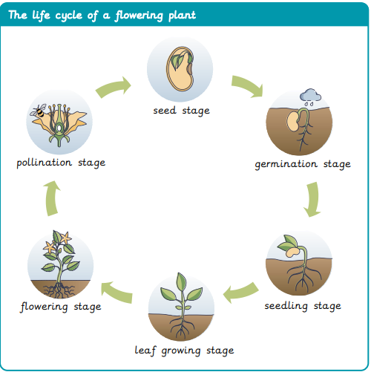

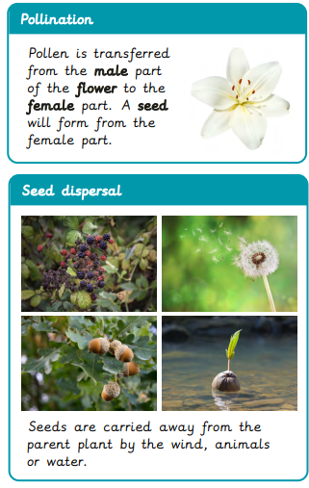

|  |  |  |  |
| --- | --- | --- | --- |
| **F:\Learning bugs\Foundation Subjects\Dolly the Fly - Science.jpgLyng Primary School Knowledge Organiser** | | | |
| ***Topic: plan reproduction*** | ***Science***  ***What is the lifecycle of a flowering plant?*** | *Year 3* | *Summer 1* |

|  |  |  |  |
| --- | --- | --- | --- |
| To grow healthily a plant needs… | **S** | | **E** |
| a) water |  |  | |
| b) chocolate |  |  | |
| c) wind |  |  | |

|  |  |  |
| --- | --- | --- |
| How do bees help plants? | **S** | **C** |
| a) By eating harmful insects. |  |  |
| b) By watering the plants |  |  |
| c) By pollinating flowers |  |  |
| d) By cooling them with their wings |  |  |

|  |  |  |
| --- | --- | --- |
| What does the stem do? | **S** | **E** |
| 1. Attract bees |  |  |
| 1. Transport water and support the plant |  |  |
| 1. Anchors the plant in the soil |  |  |

|  |  |  |
| --- | --- | --- |
| What is germination? | **S** | **E** |
| 1. A plant growing from a seed. |  |  |
| 1. Leaves falling off in autumn. |  |  |
| 1. Water transport. |  |  |

|  |  |  |
| --- | --- | --- |
| Which part of the plant absorbs water and minerals? | **S** | **E** |
| 1. leaves |  |  |
| 1. petals |  |  |
| 1. roots |  |  |

|  |  |  |
| --- | --- | --- |
| Which of these is not a seed dispersal method? | **S** | **E** |
| 1. Transported by water |  |  |
| 1. Transported on animal fur |  |  |
| 1. Jetpack |  |  |

|  |  |  |
| --- | --- | --- |
| Which of these is the role of a flower? | **S** | **E** |
| 1. To make food. |  |  |
| 1. To attract insects. |  |  |
| 1. To grow leaves |  |  |

|  |  |  |
| --- | --- | --- |
| A seed is formed after… | **S** | **E** |
| 1. Pollen transfers from the male to the female part of the flower |  |  |
| 1. The plant is placed in light |  |  |
| 1. An animal eats the fruit |  |  |

Start of quiz _________________

End of quiz ________________